CS673 – Final Project
Project Title : NYC 311 Complaints Network Analysis
Course : Scalable Databases (Fall 2025)

- Problem Definition
New York City’s 311 system serves as a centralized platform for residents to report non-emergency issues related to public services, infrastructure, housing, sanitation, and safety. Each service request is associated with multiple dimensions, including the type of complaint, the agency responsible for handling it, the geographic location where the issue occurred, and the status of resolution.
Due to the interconnected nature of these entities, analyzing NYC 311 data using traditional tabular approaches can limit the ability to efficiently explore relationships and patterns across entities. This project addresses this challenge by modeling NYC 311 service request data as a graph database, enabling direct traversal across complaint types, agencies, boroughs, and request statuses.
The primary objective of this project is to design, implement, and analyze a graph-based representation of NYC 311 service requests to uncover meaningful patterns, improve interpretability of relationships, and demonstrate the suitability of graph databases for complex urban service data. Understanding these relationships can support better allocation of city resources, identify service bottlenecks, and improve responsiveness to resident concerns.

- Explanation of Why a Graph Database Is the Best Fit for the Problem
The NYC 311 dataset exhibits strong relational characteristics, where each service request is linked to multiple entities such as complaint types, agencies, boroughs, and statuses. These relationships form a network structure that is naturally represented as a graph.
In a relational database, answering questions such as “Which agencies handle the most illegal parking complaints in Brooklyn?” would require multiple join operations across several tables. As data volume and relationship complexity increase, these queries become more difficult to construct and optimize.
Graph databases store data as nodes and relationships, allowing efficient traversal across connected entities without costly join operations. This makes graph databases especially effective for exploring multi-entity relationships, uncovering structural patterns, and performing multi-step traversals that are difficult to express efficiently using relational joins. By using Neo4j, this project leverages the strengths of graph technology to analyze NYC 311 service requests in a way that is more intuitive, scalable, and expressive than traditional relational approaches.

- Graph Database Modeling
The graph database for this project was designed using a property graph model. In this model, nodes represent real-world entities and relationships represent the connections between those entities. The central node in the graph is the service request, which connects to multiple supporting entities.
The following node types are defined:
- Request: represents an individual NYC 311 service request
- ComplaintType: represents the category of the reported issue
- Agency: represents the city agency responsible for handling the request
- Borough: represents the geographic borough where the issue occurred
- Status: represents the current resolution status of the request
Each Request node serves as the central entity and is connected to exactly one ComplaintType, Agency, Borough, and Status node. This ensures clarity, consistency, and efficient traversal across the graph. Unique constraints are applied to prevent duplicate nodes and maintain data integrity. Uniqueness constraints were applied to node identifiers such as request keys and descriptive attributes to prevent duplication and preserve structural consistency.

- Nodes, properties for nodes, label them and define the relationships between the nodes
Nodes were created in Neo4j using clearly defined labels and properties to represent each entity in the NYC 311 dataset. Request nodes store identifying and time-related information such as the unique request key and creation and closure dates. ComplaintType, Agency, Borough, and Status nodes store descriptive attributes relevant to each entity.
Relationships were defined to connect Request nodes to their associated entities. These relationships include HAS_COMPLAINT_TYPE, HANDLED_BY, IN_BOROUGH, and HAS_STATUS. Unique constraints and merge operations were used to prevent duplicate nodes and ensure data integrity. As a result, every service request in the graph is fully connected to all relevant contextual information, allowing meaningful relationship-based analysis.
The use of MERGE operations during node creation ensured that shared entities such as agencies, complaint types, boroughs, and statuses were stored only once in the graph, even when referenced by multiple service requests. This design prevents redundancy, reduces storage overhead, and guarantees that relationships accurately represent shared real-world entities. By centralizing these entities, the graph supports efficient traversal and consistent analytical results.
Figure 1: Graph visualization showing Request nodes connected to ComplaintType, Agency, Borough, and Status nodes.
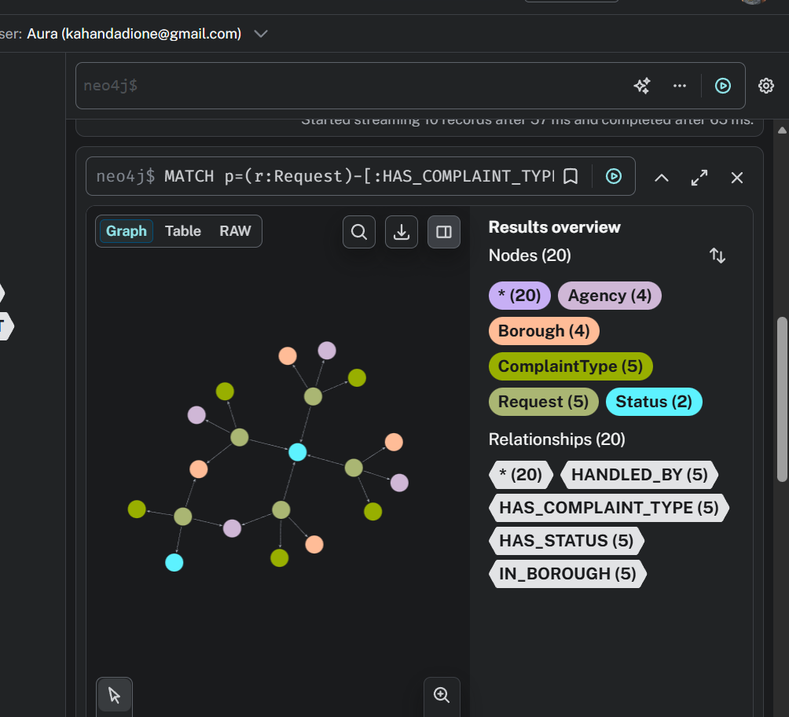

The graph shows a subgraph with 20 nodes in total: 5 Request, 5 ComplaintType, 4 Agency, 4 Borough, and 2 Status nodes. The graph also includes 20 relationships, with 5 each of HAS_COMPLAINT_TYPE, HANDLED_BY, IN_BOROUGH, and HAS_STATUS. Each Request node is connected to exactly one node from each related entity type, confirming correct graph structure and relationship mapping. The absence of isolated nodes indicates successful data ingestion and complete linkage among entities.
Figure 2: Verification of relationship creation showing total counts for each relationship type.
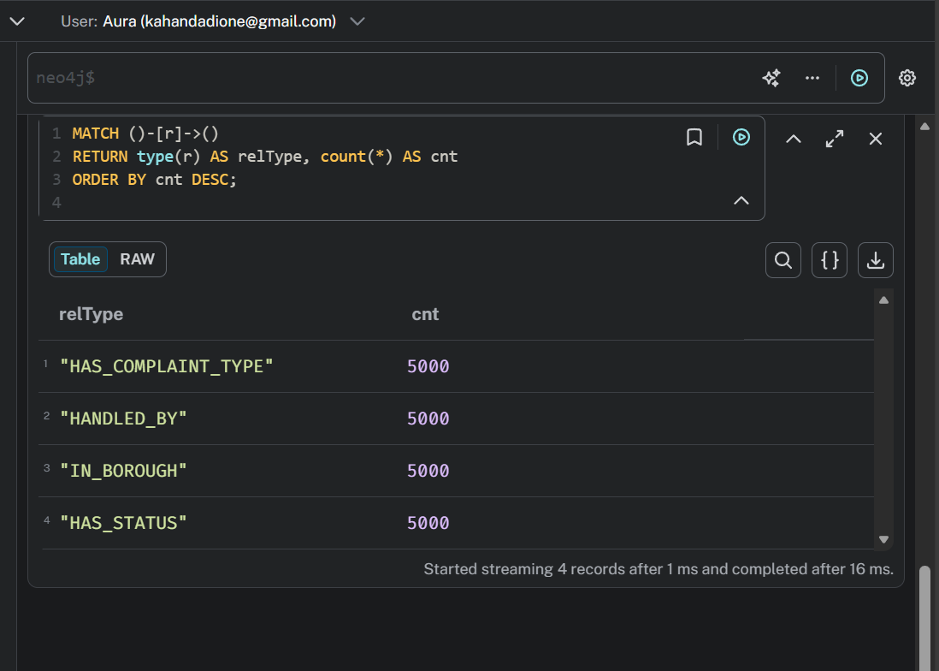
Each relationship type such as HAS_COMPLAINT_TYPE occurs 5,000 times, indicating 5,000 fully connected Request nodes. The equal counts confirm consistent relationship creation and strong data integrity across the graph.

- Cleanse your data if there are any null values
Before loading the data into the graph database, the NYC 311 dataset was cleansed to ensure data quality. Records missing essential attributes such as complaint type, agency, borough, or status were removed because these fields are required to create complete nodes and relationships in the graph.
Certain fields, such as closed date, were allowed to remain null because not all service requests have been resolved at the time of data collection. This cleansing process ensured that the graph database contained valid and meaningful connections without incomplete or orphaned nodes. This step ensured that all graph relationships were created using complete and valid records.
Figure 3: Data cleansing process showing removal of records with missing critical fields and verification of remaining null values.
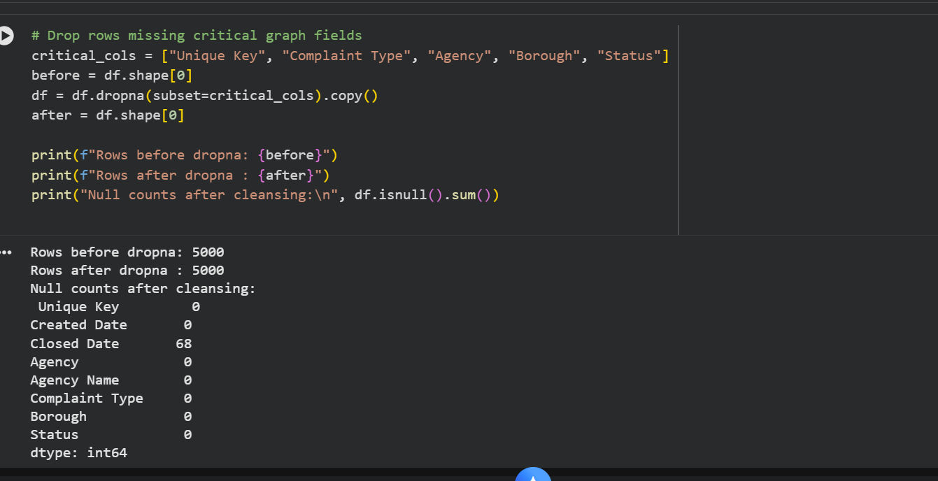
All 5,000 rows were retained after cleaning, confirming no missing values in required fields, while 68 null values in Closed Date were preserved to represent unresolved service requests.

- Data Transformation
Data transformation was performed to standardize the dataset and prepare it for graph insertion. Text-based fields such as complaint type, agency name, borough, and status were cleaned by trimming whitespace and applying consistent formatting. This prevented duplicate nodes caused by inconsistencies in text values.
Date fields were converted into a consistent datetime format to support time-based analysis. Additional derived attributes, such as request year, request month, and estimated resolution time, were created to enable aggregation and performance analysis. These transformations improved consistency and enhanced the analytical capabilities of the graph database. For example, variations in borough and agency naming were normalized to avoid the creation of duplicate nodes caused by inconsistent text formatting.

- Perform Aggregation Operations.
Aggregation operations were performed in Neo4j to summarize patterns within the NYC 311 service request data. These aggregations included counting the number of requests by complaint type, borough, agency, and request status. The results reveal which complaint categories are most common, which boroughs generate the highest volume of requests, and which agencies handle most service requests. These aggregations help identify high-demand services and potential operational pressure points across city agencies.
Figure 4: Aggregation of NYC 311 service requests showing the most frequent complaint types.
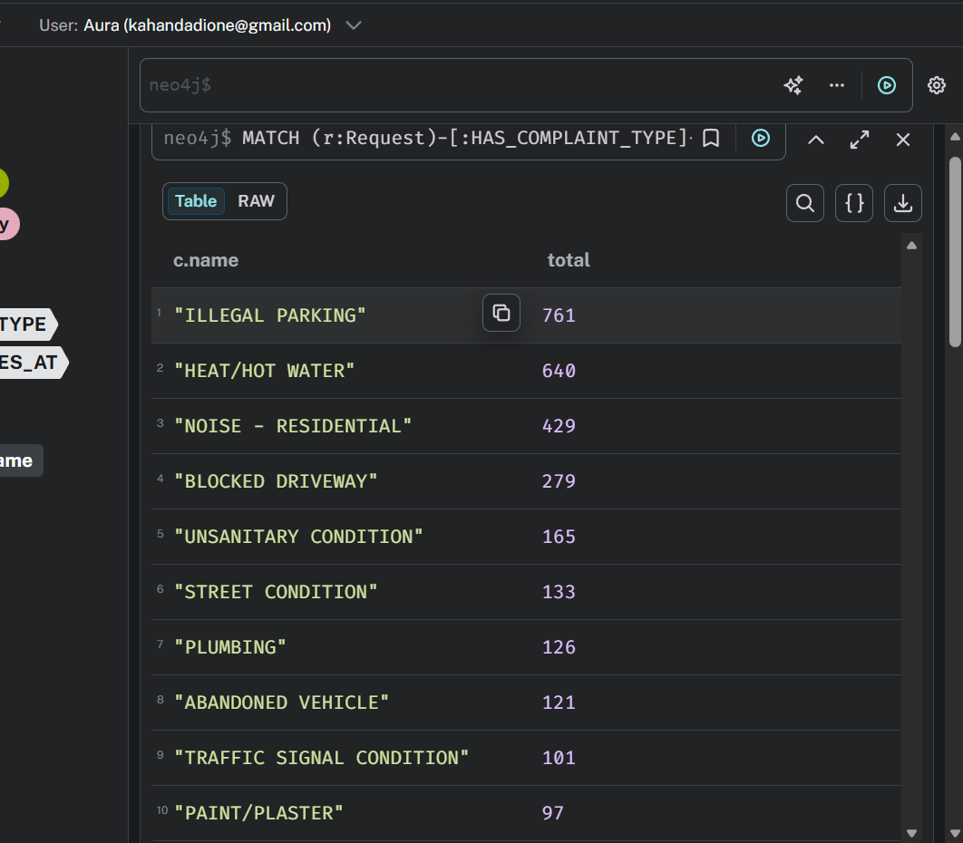

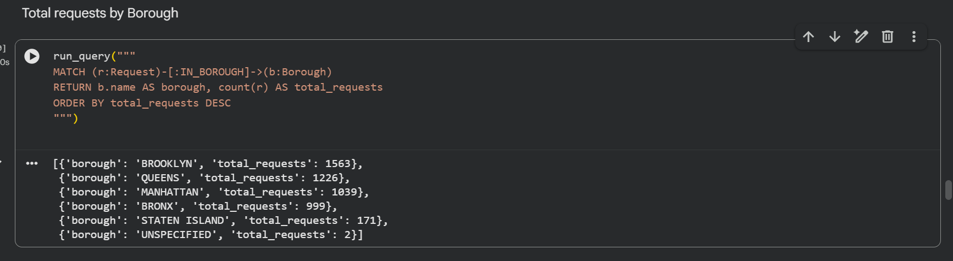

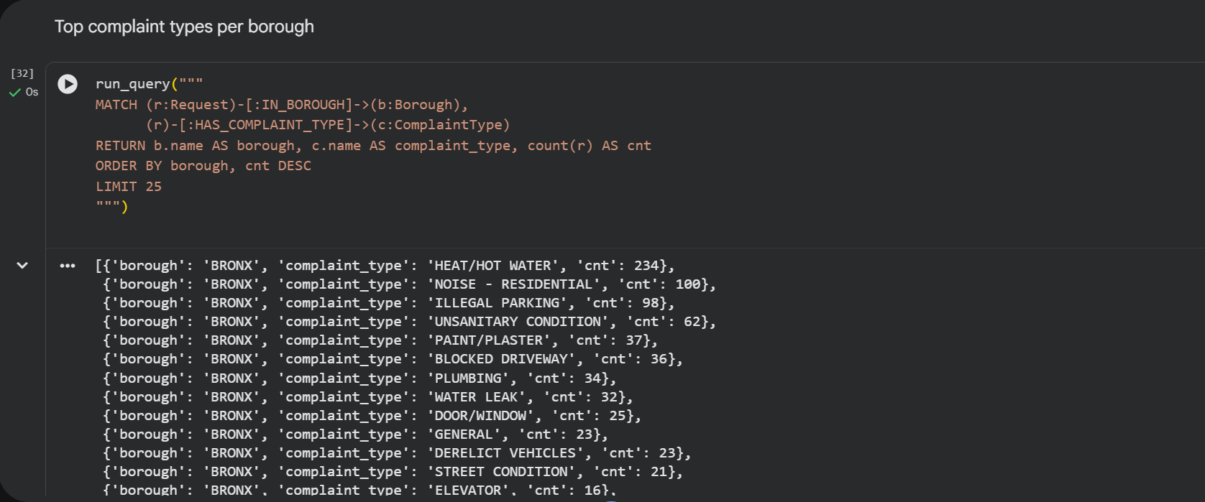
The aggregation results show that Illegal Parking (761), Heat/Hot Water (640), and Residential Noise (429) are the most common complaint types citywide, followed by Blocked Driveway (279) and Unsanitary Condition (165).
Borough-level totals indicate that Brooklyn (1,563 requests) and Queens (1,226) generate the highest volume of 311 requests, followed by Manhattan (1,039) and Bronx (999), with Staten Island (171) reporting the fewest.
The per-borough breakdown then further highlights localized patterns, such as Heat/Hot Water (234) and Residential Noise (100) being the dominant complaint types in the Bronx, demonstrating the value of graph-based aggregation for both global and neighborhood-level insights.

- Query the Graph Database
To demonstrate querying capabilities, multiple graph queries were executed to retrieve connected information across the database. These queries explored relationships between service requests, complaint types, agencies, boroughs, and statuses using graph traversal.
Examples include identifying open requests in specific boroughs, determining which agencies handle certain complaint types, and visualizing paths connecting requests to related entities. These queries demonstrate how graph databases simplify relationship-based analysis compared to traditional relational systems. Compared to equivalent SQL queries, these graph queries require fewer steps and directly reflect the underlying relationships between entities.
Figure 5: Graph visualization illustrating traversal across NYC 311 service request relationships.

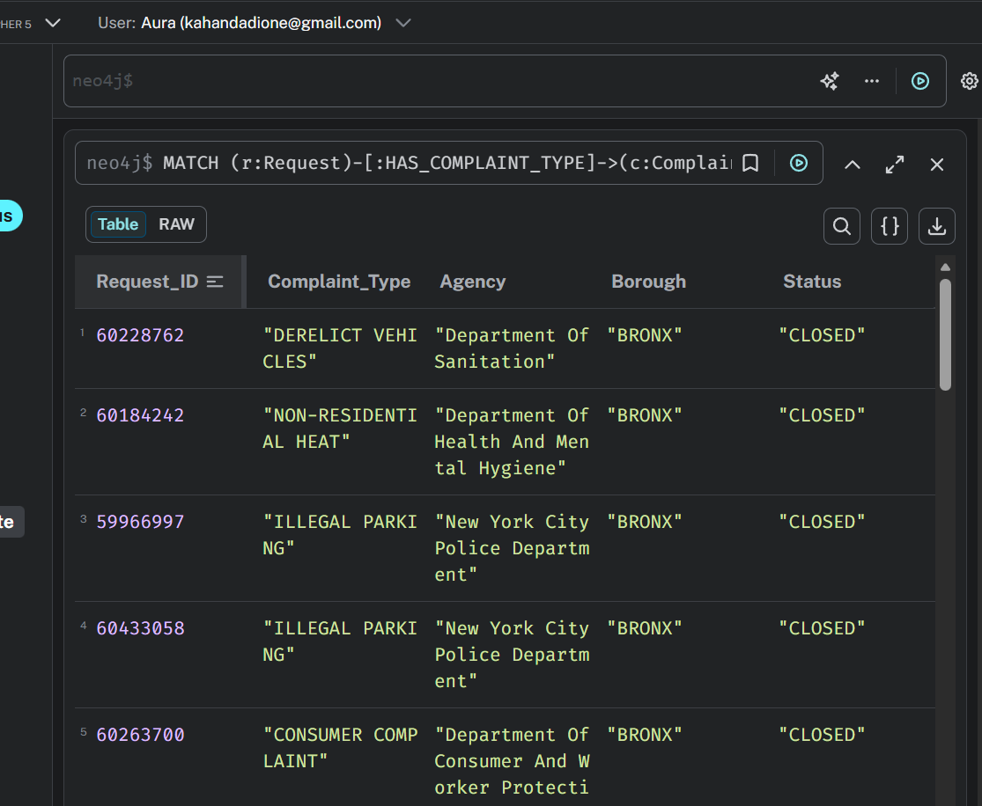
The queries retrieved individual NYC 311 requests with their complaint type, handling agency, borough, and status, showing that complaints such as Illegal Parking and Derelict Vehicles in the Bronx are mainly handled by the NYPD and Department of Sanitation and are marked closed.

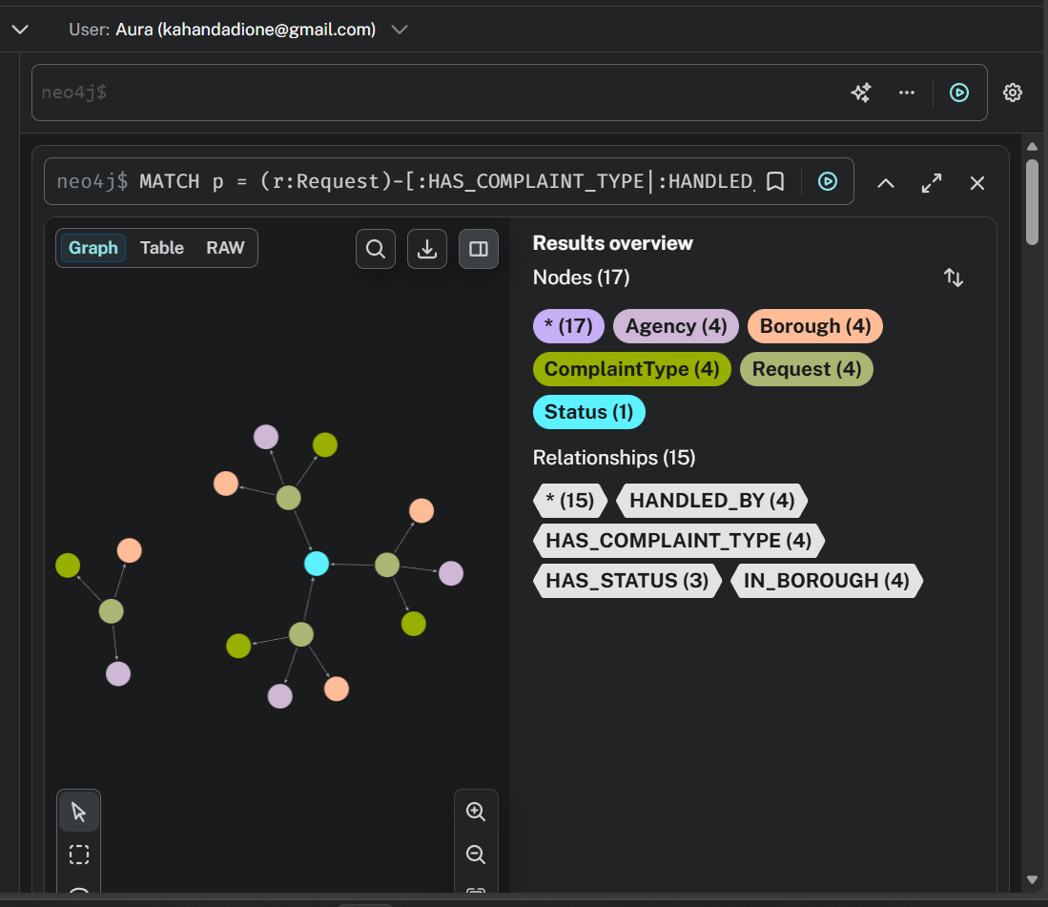
The plot visualize 17 nodes and 15 relationships, confirming correct multi-entity linkage. This demonstrates effective graph traversal across request, complaint, agency, location, and status data.
- Key Insights
The analysis shows that complaint types such as illegal parking, heat or hot water issues, and residential noise appear most frequently in the dataset. Certain agencies, particularly those responsible for enforcement and public safety, handle a disproportionately large number of service requests. Additionally, complaint patterns vary across boroughs, highlighting geographic differences in service demand. These insights demonstrate the value of graph-based analysis for understanding urban service data. The graph structure makes it easy to trace individual requests to their responsible agencies and locations, highlighting the interpretability benefits of graph-based modeling.

- Conclusion
This project demonstrates the effectiveness of using a graph database to analyze NYC 311 service request data. By modeling requests and related entities as interconnected nodes, the graph structure enables intuitive exploration of complex relationships and patterns. Compared to traditional relational approaches, the graph database simplifies querying and enhances insight discovery. This approach can be extended to larger datasets or additional entities to further support data-driven decision-making for city services.

